**Execution of Application**

**Step 1: Server is ready to handle & monitor clients.**

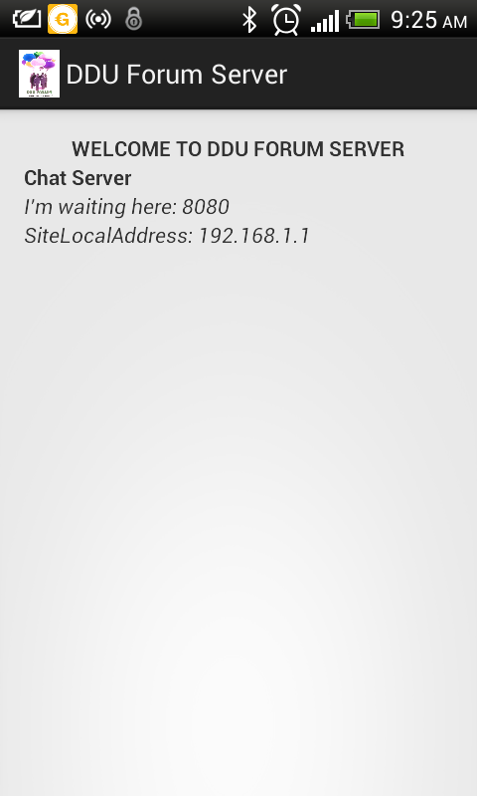

**Step 2: Client is ready to connect with server.**

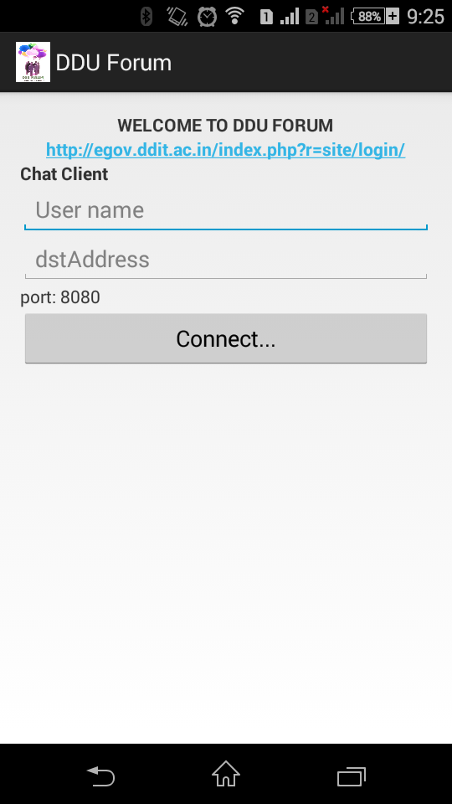

**Step 3: Client request to server for connection.**

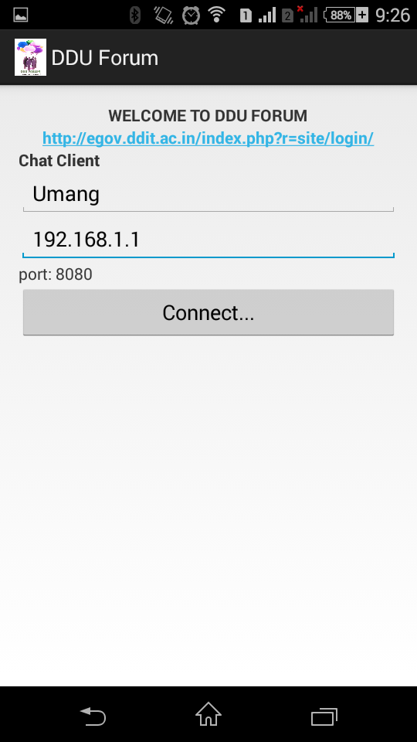

**Step 4: Server accept the connection and client is ready for chatting.**

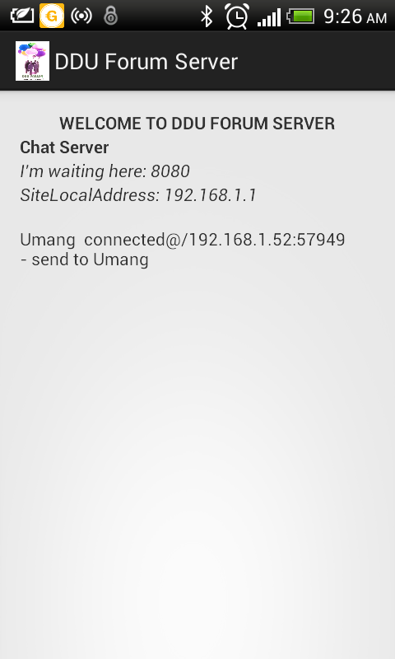

**Step 5: Client can send the message and disconnect the connection and also can go to student panel site of ddu.**

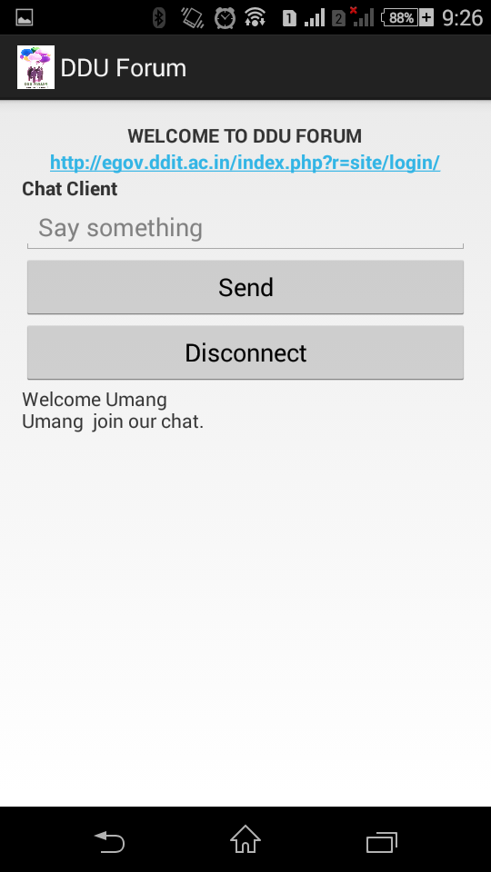

**Step 6: Client write the message and send it to another clients via server.**

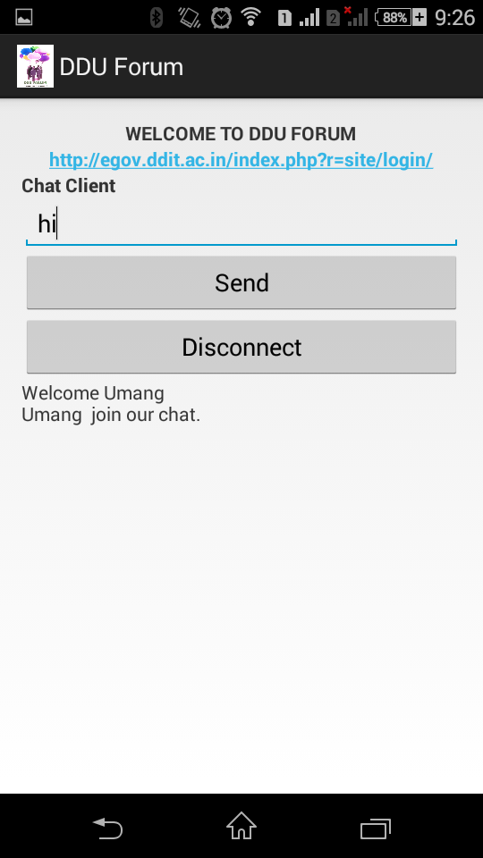

**Step 7: client sent message to another clients and it received.**

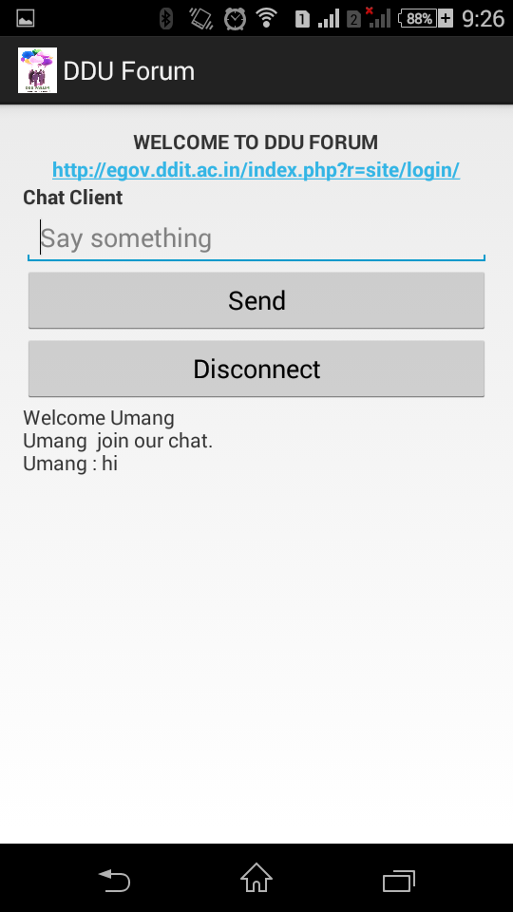

**Step 8: server can monitor all messages and make log of it.**

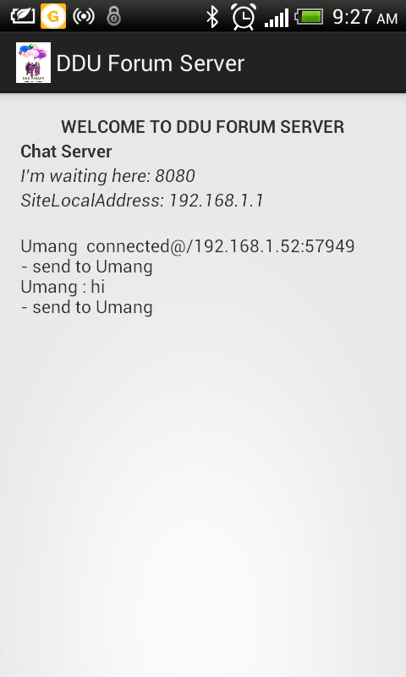

**Logo of DDU FORUM:**

